ASSIGNMENT-3

1. Select all open incidents.

select \* from Crime where status = "Open";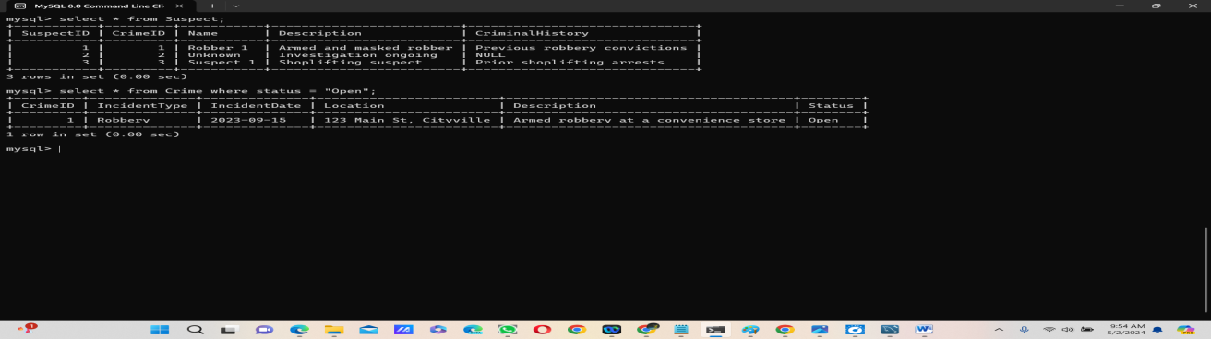

1. Find the total number of incidents.

select count(\*) from Crime;

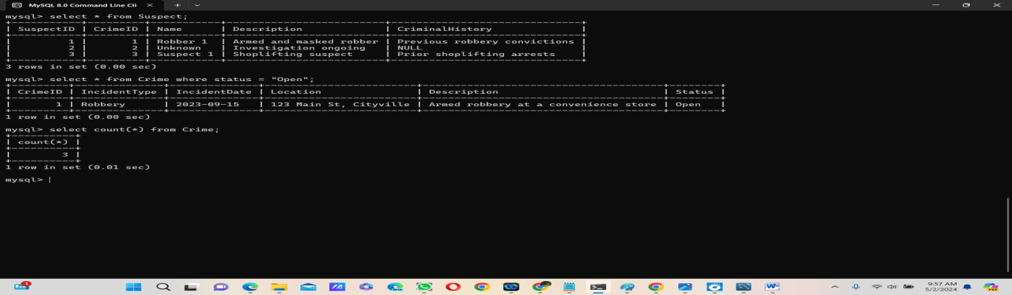

3. List all unique incident types.

SELECT DISTINCT IncidentType

from Crime; 

4. Retrieve incidents that occurred between '2023-09-01' and '2023-09-10'.

select \* from crime where IncidentDate between "2023-09-01" and "2023-09-10";



5. List persons involved in incidents in descending order of age.

select age from Victim order by age desc;



6. Find the average age of persons involved in incidents.

select avg(age) from Victim;



7. List incident types and their counts, only for open cases.

select IncidentType,count(\*) from Crime

where status = "Open" group by IncidentType;



8. Find persons with names containing 'Doe'.

select Name from Victim

where Name like "%doe%";



9. Retrieve the names of persons involved in open cases and closed cases.

select Name ,Status from Crime JOIN Victim ON Crime.CrimeID=Victim.CrimeID where status IN("open","closed");



10. List incident types where there are persons aged 30 or 35 involved.



11. Find persons involved in incidents of the same type as 'Robbery'.

select distinct v.Name

from Victim v

inner join Crime c on v.CrimeID = c.CrimeID and c.IncidentType = 'Robbery';



12. List incident types with more than one open case.

select IncidentType from Crime where Status = 'Open'

group by IncidentType having count(\*) > 1; 

13. List all incidents with suspects whose names also appear as victims in other incidents.

select \* from Crime

where CrimeID in (select CrimeID from Suspect

where Name in (select Name from Victim));



14. Retrieve all incidents along with victim and suspect details.

SELECT c.\*, v.Name AS VictimName, s.Name AS SuspectName

FROM Crime c

LEFT JOIN Victim v ON c.CrimeID = v.CrimeID

LEFT JOIN Suspect s ON c.CrimeID = s.CrimeID;



15. Find incidents where the suspect is older than any victim.



16. Find suspects involved in multiple incidents:

SELECT Name

FROM Suspect

GROUP BY Name

HAVING COUNT(\*)>1;



17. List incidents with no suspects involved.

SELECT \* from Crime where CrimeID NOT In ( Select CrimeID from Suspect);



18. List all cases where at least one incident is of type 'Homicide' and all other incidents are of type 'Robbery'.

Select \* from Crime where IncidentType = “Homicide” and CrimeID in (select CrimeID from Crime where IncidentType = “Robbery”);



19. Retrieve a list of all incidents and the associated suspects, showing suspects for each incident, or 'No Suspect' if there are none.

SELECT c.CrimeID, c.IncidentType, s.Name AS SuspectName

FROM Crime c

LEFT JOIN Suspect s ON c.CrimeID = s.CrimeID;



20. List all suspects who have been involved in incidents with incident types 'Robbery' or 'Assault

